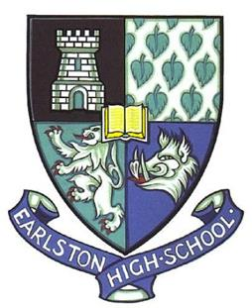

THE
EARLSTON HIGH SCHOOL
CELEBRATION OF
SUCCESS
AWARDS
- 30 March 2015 -

Programme
Of
Events

Information about our main sponsors
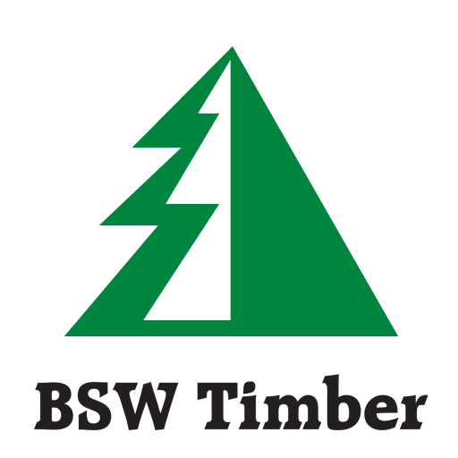
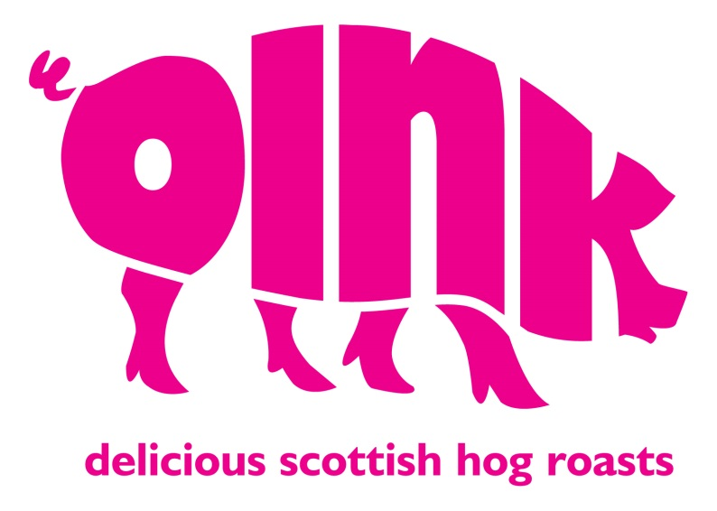

BSW Timber is the largest sawmilling business in Great Britain and the company's foundations go back to 1848.
BSW sawmills are located throughout the UK, at Fort William, Boat of Garten, Petersmuir, Dalbeattie, Carlisle, Southampton and Newbridge-on-Wye in Wales and we have one sawmill in Riga, Latvia. Group Headquarters remain in the town of Earlston in Berwickshire, where the business originated. Today the firm employs 1000 people in the UK and Latvia, turnover is in excess of £220 million. A dedicated Customer Sales Centre at our Carlisle mill ensures that all our customers receive specialised and dedicated help - consistently.
We continue to invest in our manufacturing facilities and technology and in market research, product and market development, bringing new opportunities to our customers using both UK and Latvian fibre. We are continually looking at ways to improve product availability and customer service.

OINK – Delicious Scottish hog roasts
Enjoy a freshly carved hog roast roll from Oink at their restaurants in Edinburgh’s Victoria Street and Canongate. Oink will also go the whole hog for your event or party with their superb outside catering business.
Discover for yourself why Oink has been recognised as one of Yelp’s top 100 restaurants in the whole of the UK.
www.oinkhogroast.co.uk
T: 018907 61355

EHS Celebration of Success 2015

Welcome to Earlston High School’s Celebration of Success, 2015

Programme

Introduction: Mr Chapman, Depute Head Teacher

Faculty Awards

Guest Speaker: Nichola Sewell, Health Improvement, NHS

Wider Achievement Awards
Presented by Nichola Sewell, Health Improvement, NHS

Volunteering Awards:
Presented by Susan Swan, Executive Officer Volunteer Centre Borders

House Awards:
Presented by Miss Pate, Teacher of Physical Education

Music: Smoke Gets In My Eyes – Becky Farnish

Hall of Fame
Presented by Mr Chapman, Depute Head Teacher

Team of the Year
Presented by Mr Changleng – Principal Teacher of Health and wellbeing

Thanks –Miss Strong, Head Teacher

Event compered by S6 Head Team (Rhona Callow, Joseph Flynn, Rachel Magowan and Calum McDonald)
EHS Celebration of Success 2015
FACULTY AWARD WINNERS

Faculty Awarded to Kindly Sponsored By

Behaviour Support

Peer Mentors Gavin McQuarrie
Jacob Tracey

English
English Rosie Brosnan Masons of Melrose
Literacy Archie Kidd The Southern Reporter
Senior Champion Cullen Cockburn Main Street Trading Company
S4 Champion Corran MacFarlane Main Street Trading Company

Expressive Arts
Music Becky Farnish
Art & Design Joanna Holisz
Drama Ashley Parker Borders Studio

Health and Wellbeing
PE Archie Kidd Oink
Home Economics Lucy Melrose Rettie & Co

Humanities
Modern Studies Gemma Watson
Geography Megan Gilmour
History Emma Beattie
RMPS Mia Sneddon

Maths
Maths Ambassador Aaron Dornan Hogg and Thorburn
Cipher Challenge Finlay Anderson
Callum Barclay
Kale Haswell
Mary Hall

Modern Languages
French Elizabeth Bowie
German Jenni Stevenson
Spanish Lucie Billet

Science
Biology Kirsty Lennon
Chemistry Aaron Dornan
Mary Hall
Physics Paul Henney

Technologies
Business Management Ruth Aitken
Sophie McBrayne Carfraemill Hotel
Practical Woodworking Tom McKinlay
Adam Hall BSW Timber
Engineering Science Rowan Cunningham
Design and Manufacture Katrina Niven Wilson Builders and Joiners Ltd
Graphic Communication Amy Lillico User Friendly Computing Ltd

SCHOOL & COMMUNITY ACTIVITIES
EHS Celebration of Success 2015

Activity Awarded to Kindly Sponsored By

Exceptional Commitment
to School Clubs/Activities
Music Gregor Milligan
School Show Daniel Kaczan
Roan Torrance
Sport Charmaine Chisholm Oink
Other Clubs Molly Watson Maid by Marion

ASDAN (certificates)
Bronze Rhiannon Girling, Daniel Millan,
Sophie Ramsay
Silver Shannon Kerr, Duncan Swanston,
Kai Robertson, Stephen Hall,
Beth Redpath, Jade Stewart

College Commitment Chloe Thorburn

Work Experience Ryan Snook Encompass

Community Award Earlston Youth Club Committee Greenside Veterinary Service
Aimee Sloan, Isla Reid, Caitlin Allan,
Amelia Adams, Maude Adams

Volunteering
Saltire Isla Gibb, Rosie Reilly, Mhairi Milne,
Gemma Watson
Community Inspire Award Media Group
Kerr McNicoll, Natalie Goodall,
Sarah Robbins, Max Timoney,
Corran Mc Farlane, Thomas Billam,
Patrick Heger, Alexander Cowan,
Leon Black
Borders Young Coach Programme
Lindsay Maguire, Dylan Fagan,
Joanna Holisz, Ciara Donlevy
Volunteer of the Year Ciara Donlevy John Swan

Service to the School Duncan Swanston Parent Council
(School garden & fundraising)

Representing Others/
Equality and Diversity Becky Farnish

House Awards
Top Boy Finlay Anderson
(across a range of categories)
Top Girl Richeldis Brosnan
(across a range of categories)
Excellent classwork Lauren Purves
Winning House to be announced on the evening
House Captains to be announced on the evening
HALL OF FAME – National Level Achievement
EHS Celebration of Success 2015

Laura Munro Athletics
Emily Dagg Athletics
Gavin Bryson Hill Running
Yousuf Khursheed Orienteering
Faisal Khursheed Orienteering
Leia MacKinnon Hockey
Lucy Inglis Hockey
Thoma Klein Rugby
Chrissie Johnson National Youth Orchestra
Catriona Lamb National Youth Choir
Mitchell Green National Youth Choir
Jack Magee Cartoonist
Andrew Wilkinson Judo
Imogen Walls Judo
Shannon Purves Vaulting
Ciara Donlevy Trampolining
Alysha Murray Irish Dancing
Lizzie Clelland Swimming
Tanith Bain Taekwondo
Ross Thomson Skiing

Team of the Year
Under 18 Rugby Winners of Scottish Schools Plate 2015

Also
Congratulations to recently elected MSYP Corran McFarlane, Ettrick, Roxburgh & Berwickshire

Thank you
EHS Celebration of Success 2015

to the many organisations that generously sponsored our event this evening.
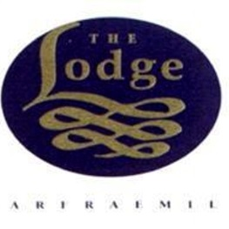

Masons of Melrose

Wilson Builders & Joiners Ltd The Trophy Guy
Earlston High School
Parent Council

Programme designed by Earlston High School Media Group

