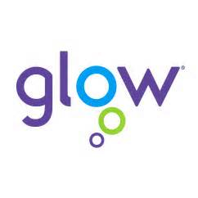

Using GLOW for recording personal achievements

Notes for Students

Username ___________________________
Password ____________________________

Steps to access your own Achievement Book
Teachers will remind you of your username and password to start this off. Googling ‘Glow log-in’ will also get you to the site

- Log into GLOW at https://glow.rmunify.com/
- Click on the icon for the school’s GLOW site
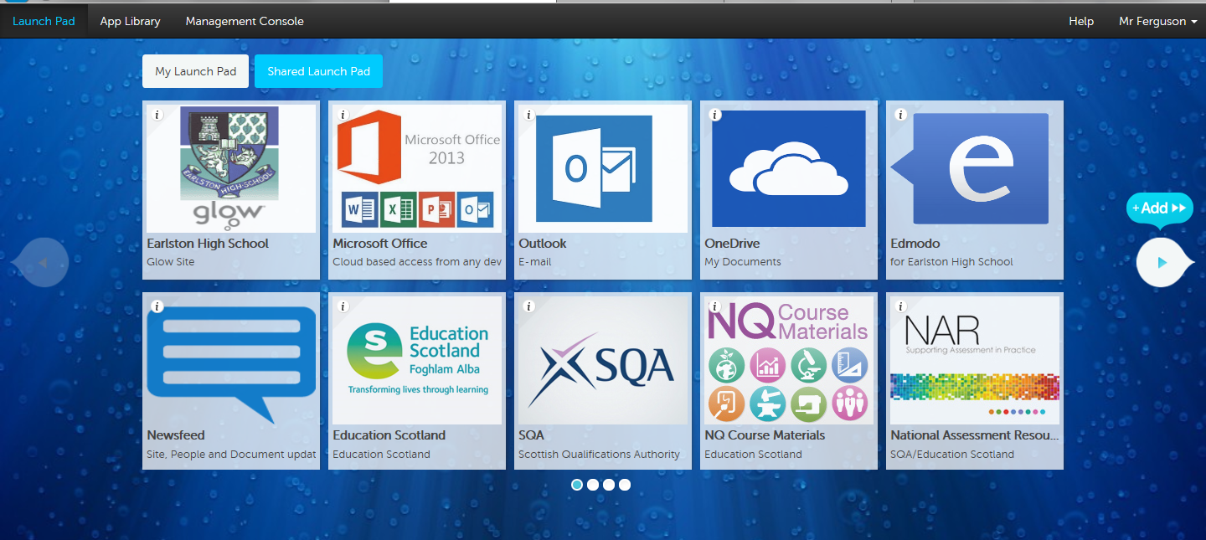
- Click on Class Notebooks then Documents and then E-Portfolios

- This will give you access to your class achievement book – eg Teviot2014, Tweed 2012 etc. From here you will be able to access your own individual pages. Note that each student can only see their own page and each of the general information pages.
What the Achievement book looks like

There will be pages for each of the following areas:
- Out of School Achievements
- Schools Clubs and Groups
- Leadership
- Subject Achievements
- Work Experience and Volunteering
- House Events
- School Trips and Excursions
- Careers Planning
Click on the page that you want to add a post to and simply click on the + sign to add this.
For each post, you just need to add a few sentences about what the particular achievement is and also note skills and/or Curriculum for Excellence capacities. Information about these and other notes are available in the Content Library section. This area also has samples of posts and links to key websites.
Examples are also on the Guidance website at http://ehsguidance.weebly.com/e-portfolios.html

Sample posts

S1
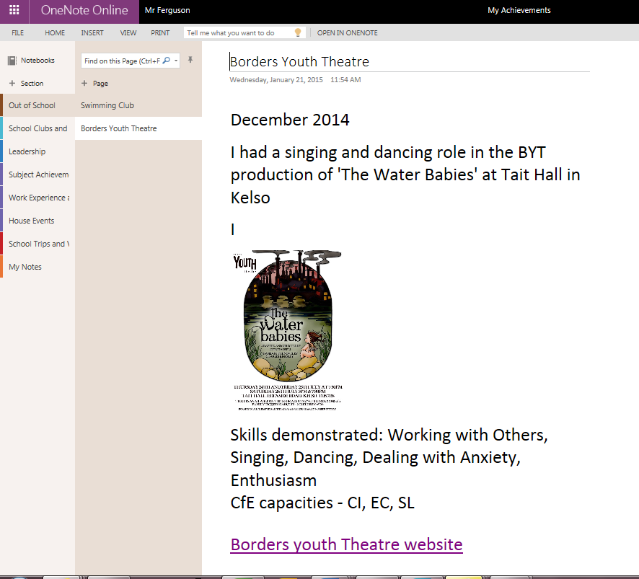
S5
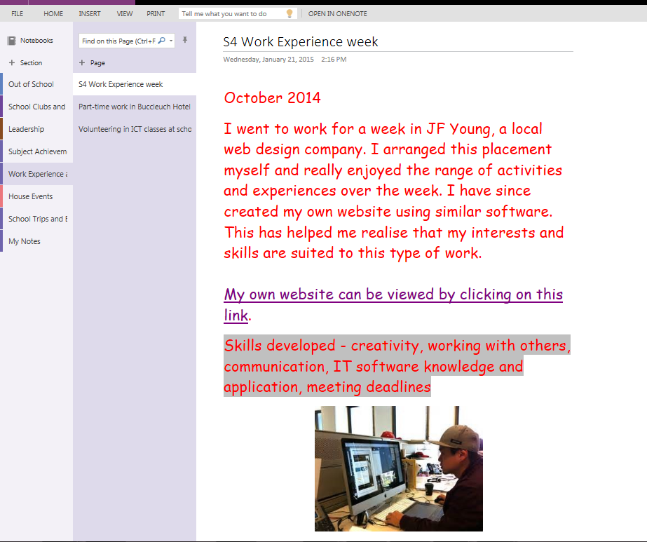
You are able to add photos and links and change font, colours and other formatting to make the posts look more presentable and easy to read

